**CSE 316**

**MICROPROCESSOR & MICROCONTROLLER SESSIONAL**

**FINAL REPORT**

**QUADCOPTER CONTROLLED BY ANDROID APP**

**SUBMITTED BY:**

**FAHIM AHMED (1305053)**

**MOBILE: 01521220336**

**MIRZA MASFIQUR RAHMAN (1305035)**

**MOBILE: 01521253391**

***YOUTUBE VIDEO LINK:*** <https://youtu.be/rNiu7enE0T8>

***FEATURES IMPLEMENTED:***

* **THE QUADCOPTER IS CONTROLLED BY BLUETOOTH**

**FROM AN ANDROID APP**

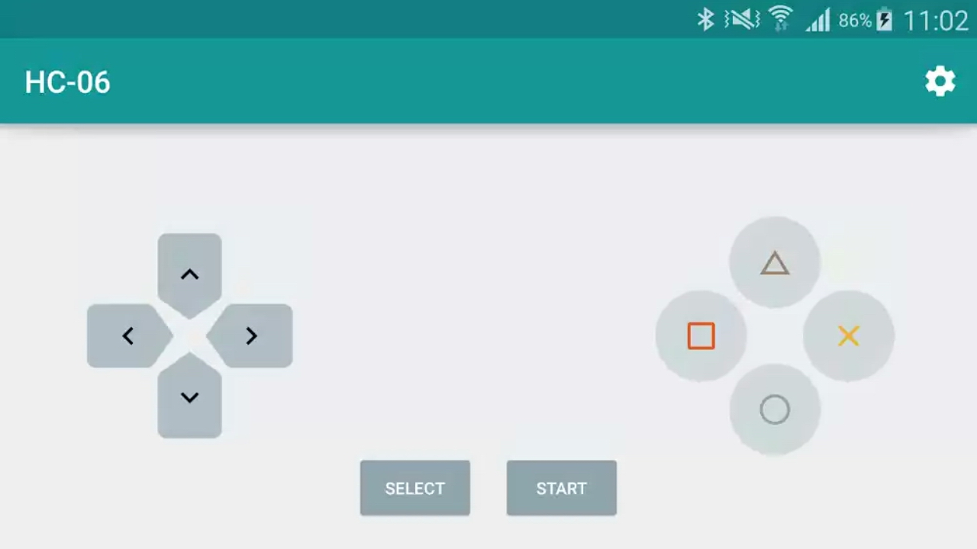

***FEATURES HAD NOT BEEN IMPLEMENTED:***

* **OBSTACLE DETECTION BY SONAR SENSOR.**

***BASIC DESCRIPTION:***  Basically our main project was to build a quadcopter which can be controlled by an android app and the communication medium will be Bluetooth. Also it will have the ability to detect obstacle near it to avoid collision. So we have built a quadcopter which can be controlled by Bluetooth . We can control the speed of this quadcopter by an android . We can control the direction of movement, rotation, altitude etc.

The hardware and software setup was successful as needed.

But the copter was not weight balanced . Also we noticed that , the motors were not rotating at the same rpm in spite of giving same pwm signal from the same pin(PD5) of the microcontroller Atmega32. That’s why the flight test of the quadcopter was not successful.

Because of these problems , we were unable to add the sonar sensors in our copter.

But all the other functions are running properly. We can increase the rpm of every motor using the android app.

Hope we can fix the flight problem in future .

***WORKING PRINCIPLE:***

* **FLOW CHART:**

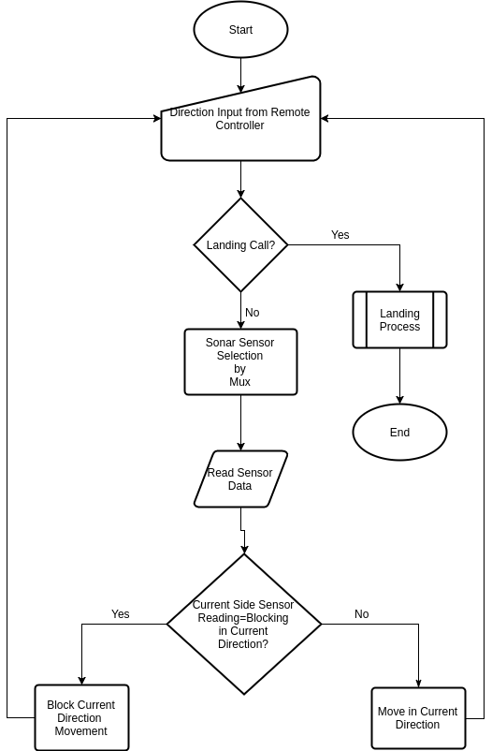

* **CIRCUIT DIAGRAM:**

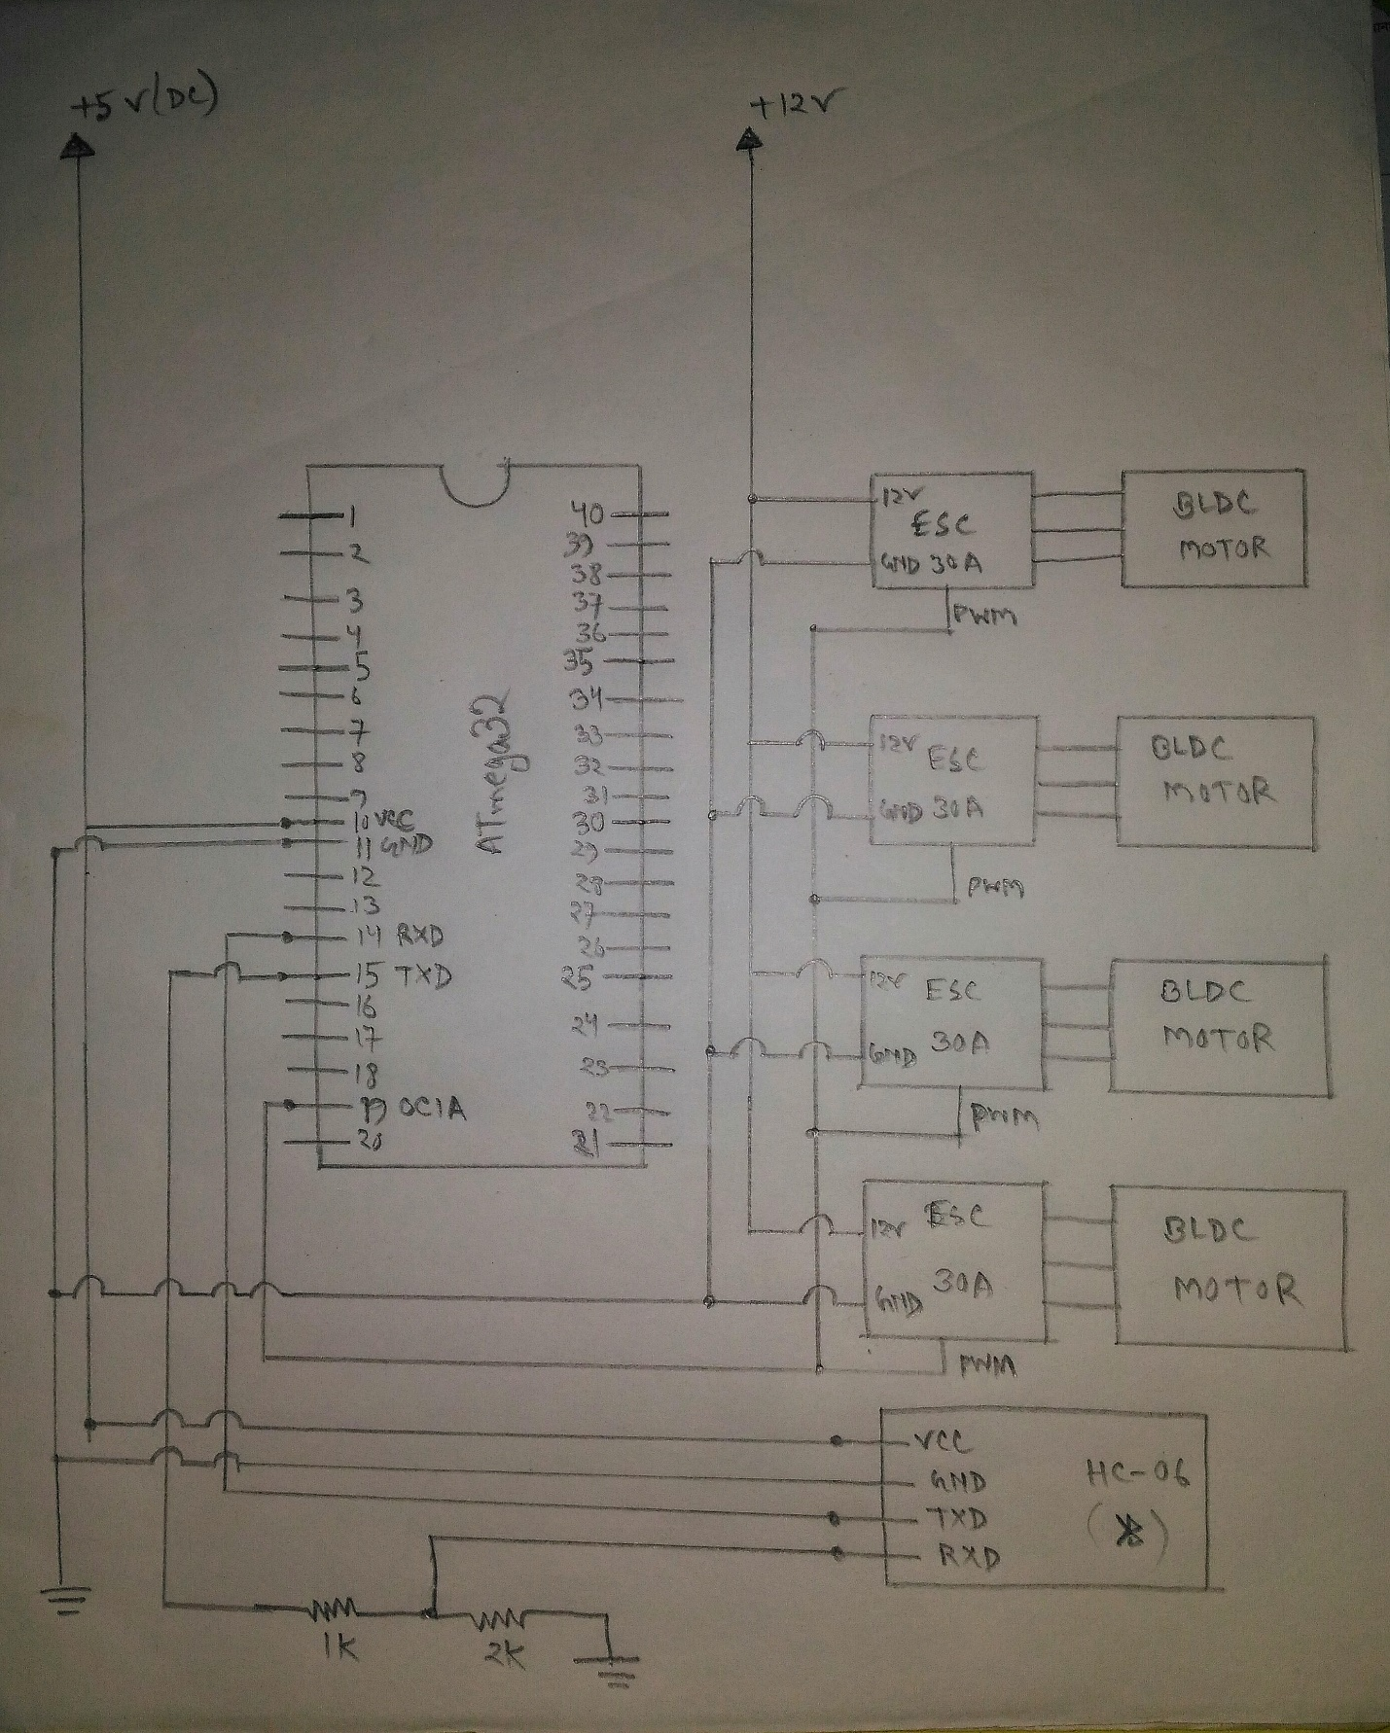

***INTERFACING WITH DIFFERENT SENSORS:***

**We haven’t implemented any sensor. We used a Bluetooth module HC-06 which was used to connect the quadcopter with an android app.**

***PROBLEMS AND CHALLENGES:***

**The first problem was to run the BLDC motor. As it is very hard to find a person who have made a quadcopter with atmega32, so we didn’t get enough help. And resources in the internet was not rich as very few person tried to make a quadcopter with atmega32. After so many browsing we were able to calibrate the ESC (electronic speed controller) which is used to control the rpm of the motor. Than we tried to use the RC flight controller. But if we use RC, there is no need of amega32. So we avoided rc and was looking for alternate wireless communication device to control our quadcopter. And decided to use HC-06 bluetooth module. Then we established Bluetooth communication through an android app.**

**To control the speed of the motors, a pwm signal is sent to every ESC and the ESC drives the motors based on the signal. But the problem is, in atmega32, there are only two pwm pins (PD4,PD5)**

**, but we have 4 motors to control. So it is impossible to control the rpm of the motors individually. So after a lot of thinking, we managed to generate pwm signal manually in any pin of the atmega32, and with this, we can control as many motors as needed individually. We used both codes.**

**So we have solved all these problems as we faces.**

**But the last problem we faced when we run our first flight test. The quadcopter was not balanced , and it was not stable in its position, and it became quite risky to run the tests further as the copter was not behaving as we anticipated. And also the time was running out. So we were compelled to finish our work as it was. We could not solve the final problem we faced.**